Hierarchies (ˈhaɪərɑ:kɪ) in Calculation View

Unassigned Member Null Handling Hierarchy in Calculation View

Often occurs that there will be entries in fact table for which corresponding master data doesn’t exist, for instance sales records for unregistered customers. In such cases when the two tables joined together with referential integrity, sales data for unregistered customers will be lost. Using the feature Unassigned Member Null Handling in hierarchy, we can see the whole data in a hierarchical fashion without any loss of data wherein the not assigned member/unregistered customer details will be grouped under a node.
This can be achieved by using SAP HANA Modeler studio and MDX client.
I am going to use below data tables PC_EMPLOYEE and PC_SALES. PC_EMPLOYEE has records in a parent child relationship. And there are values in PC_SALES table for which there is no corresponding master data exists in PC_EMPLOYEE table ex: FOO.

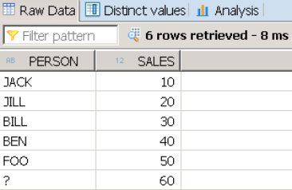

Now let us see it in a hierarchy with grouping all not assigned members together.

Step 1: Create dimensional calculation view with PC_EMPLOYEE table as shown below

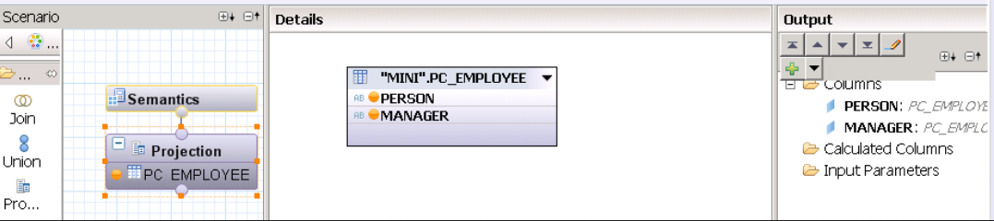

Step 2: Create a parent child hierarchy with PERSON as child and MANAGER as parent as shown below.

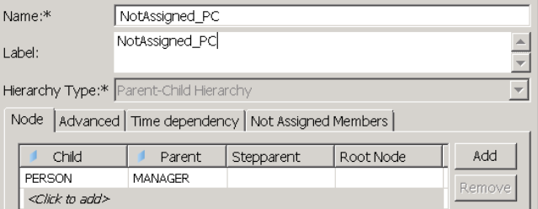

If your data is in levels, level hierarchy can be created. The feature is applicable for both level and parent child hierarchies.

Step 3: Enable Not Assigned Members by giving a name for grouping all unassigned members as highlighted below
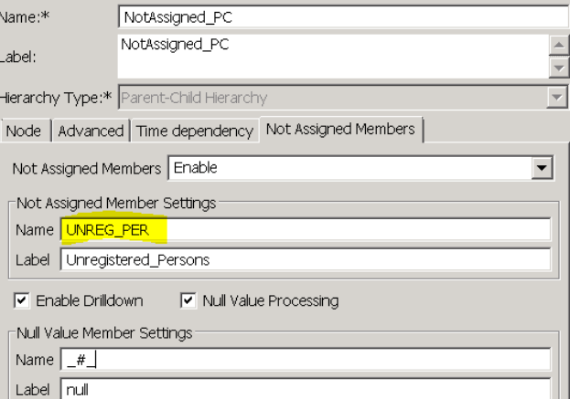

Step 4: Once dimensional calculation view is activated, it generates a columnview [“_SYS_BIC”.”shireesha/CAL_DIM_PC_EMP/hier/NotAssigned_PC”] for hierarchy under _SYS_BIC where not assigned members will be ignored as below. (Person FOO is ignored in the hierarchy)

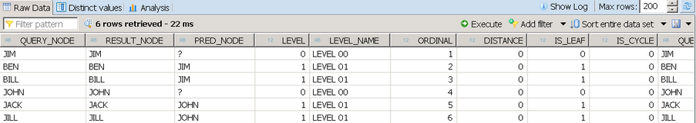

To achieve the Unassigned member handling dimensional calculation view should be consumed in a star calculation view.

Step 5: Consume above dimensional calculation view in a star calculation view by using PC_SALES as fact table.

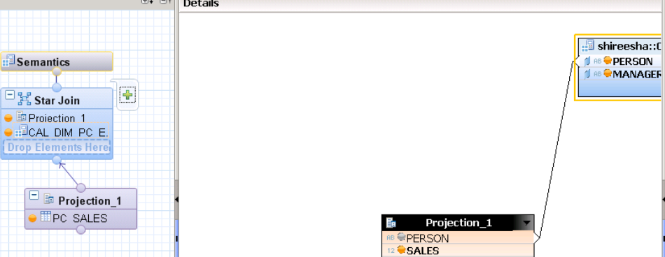

Step 6: Once star calculation view is activated there will be two column views generated for hierarchy under _SYS_BIC column views folder, one with hierarchy name and another with ending $NA.

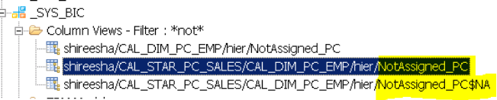

The second column view contains only the details of Not assigned members as below
The first column view consists the whole data along with the not assigned members

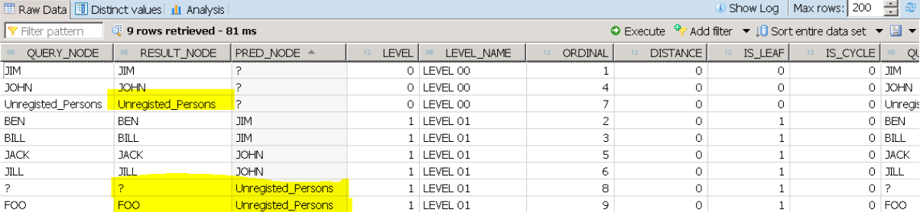

This is how not assigned members can be handled. To see the output in hierarchy the star calculation view should be consumed in any HANA client tools as MDX, Analysis Office or Lumira, etc.
Null Values also can be handled by enabling Null Processing and to denote null values specially in the hierarchy can be represented by mentioning under Null Member Settings.

Check if level in any dimension hierarchy is

[Year - Week - Date] and [Year - Month - Date]
I want to check in a Cube Calculation if the current level of the Date Dimension is [Date] (the lowest level) or something higher.
How can I achieve this?
Background: I need this to calculate how many working days there were in a period, for an employee. I currently have this code (untested) that should do the trick for 1 hierarchy, but I guess this will fail when users are using the [Year - Week - Date] hierarchy.

CASE
WHEN [Date].[Year - Month - Date].CURRENTMEMBER.Level IS [Date].[Year - Month - Date].[Date]
THEN
//at day level,
//if there is any duration booked, this is a working day
IIF([Measures].[Duration] = 0,0,1)
ELSE
//at higher than day level,
//count days
COUNT(
// where duration > 0 (employee work day)
FILTER(
Descendants([Date].[Year - Month - Date].CURRENTMEMBER, [Date].[Year - Month - Date].[Date]), [Measures].[Duration] > 0
)
)

END

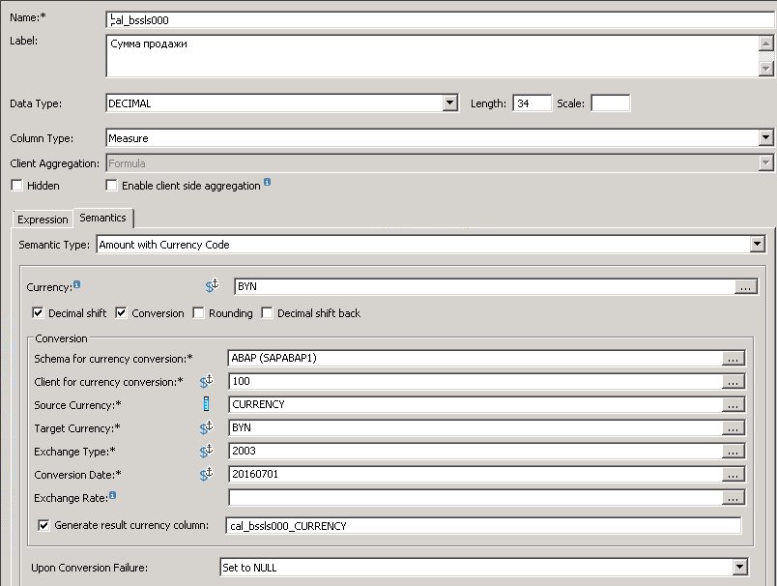

Extract Semantics from Columns and Hierarchies Select the hierarchies that have to be propagated

SAP HANA- ADVANCE MODELING FEATURES
https://blogs.sap.com/2014/05/21/sap-hana-advance-modeling-features-part-ii/

The different values for node styles –
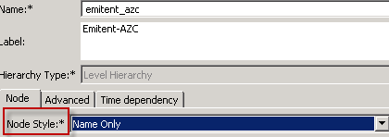
are -
- Level Name – the unique node ID is composed of level name and node name, for example [Level 2].[B2].
- Name Only – the unique node ID is composed of level name, for example B2.
- Name Path – the unique node ID is composed of the result node name and the names of all ancestors apart from the (single physical) root node. For example [A1].[B2].

The level type - 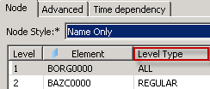 is used to specify formatting instructions for the level attributes –
- LEVEL_TYPE_TIME_MONTHS can indicate that the attributes of the level should have a text format such as January;
- LEVEL_TYPE_REGULAR indicates that a level does not require any special formatting.

Advanced tab

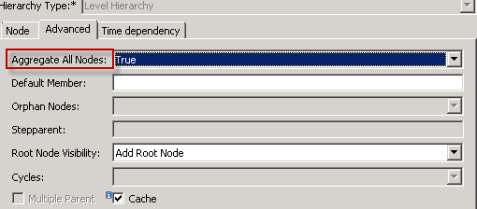

Aggregate All Nodes - data is posted on aggregate nodes and should be shown in the user interface. If you are sure that there is no data posted on aggregate nodes you should set the option to false. The engine will then calculate the hierarchy faster as when the option is set. Note that this flag is only interpreted by the SAP HANA MDX engine. In the BW OLAP engine the node values are always counted.

Orphan Nodes
To specify how to handle the orphan ('ɔːf(ə)n) nodes in the hierarchy, select the required option as described below from the dropdown –
Option | Description
Root Node | Treat them as root nodes
Error | Stop processing and show an error
Ignore | Ignore them
Step Parent | Put them under a step-parent node  Note This enables you to create a text node and place all the orphaned nodes under this node.

Stepparent ('stepˌpeər(ə)nt)
If you have selected Step Parent in the Orphan Nodes drop-down, enter a value to create the step-parent node.

Root Node Visibility
Select the Add a Root Node check-box if required.
If a hierarchy does not have a root node but needs one for reporting use case, select this option. This will create a root node with the technical name ALL.

Multiple Parent
If the level hierarchy needs to support multiple parents for its elements for example, Country Turkey to be assigned to two regions Europe and Asia, select the Multiple Parent check-box.

В базе данных возникла следующая ошибка - SAP DBTech JDBC: [258]: insufficient privilege. Дпя получения дополнительных сведений об этой ошибке см. SAP Knowledge Base Article 2054721 на портале SAP Support Portal. (IES 10901)

Connecting MS Excel to SAP HANA using MDX
I can do that with Excel. If I had been given a dollar for every time I heard that phrase back when I was implementing SAP solutions, I would be close to millionaire. Sure, MS excel is a powerful tool for small datasets and there are many users out there who can make wonderful things with it. What if those users could leverage the power of SAP HANA in their spreadsheets? I think magic could happen.
We can quickly enable the magic with Multi-Dimensional Expressions (MDX). The SAP HANA MDX Provider for MS Excel was actually released some years ago and is included in the SAP HANA Client (which can be downloaded from SAP Software Download Center).
It allows us to connect to our SAP HANA instance, query an existing Calculation (or Analytical) view and then display it in a Pivot Table or Chart.
Last but not least, a small warning for importing data into SAP HANA from an Excel spreadsheet - Sometimes, MS Excel shows a format but is internally saving something different. I generally convert the file to CSV and open it in a plain-text editor to verify the date formats are correct and there are no additional hidden decimals in my IDs, for example.

As Excel does not have the option for input parameters, it does not work (so it won’t work with mandatory input parameters).

New Hierarchy SQL enablement with Calculation Views in SAP HANA 1.0 SPS 10
https://blogs.sap.com/2015/07/09/new-hierarchy-sql-enablement-with-calculation-views-in-sap-hana-10-sps-10/

− How can I show hierarchy wise data in SAP HANA sp12 Calculation View?
I've a table A_PRODUCT_MASTER with some columns - Level1, Level2, Level3. Such that Level 1 being the parent node and Hierarchy is as follows - Level1 -> Level2 -> Level3. I want to show Level-wise Sale_qty. (sale_qty can be acquired from table A_ITEM_SALES).
I've to achieve this in a calculation view when users come with hierarchial requirements. I've found a link where we can show hierarchies in Variables while viewing the data preview, but I'm unable to implement the same in my case. Will share the link here. – Prathamesh H

− I have prepared a second solution for you using SQL RollUp clause. You can also check for other aggregation functions like Group By Grouping Sets and Cube besides RollUp functionality on SQL.

select distinct
levels.Level1, levels.Level2, levels.Level3, SUM(sums.Qty) as Totals
from (
select distinct level1, level2, level3
from product_master
union all
select distinct level1, level2, NULL as level3
from product_master
union all
select distinct level1, NULL as level2, NULL as level3
from product_master

) as levels
left join
( select Level1, Level2, Level3, Qty from PRODUCT_MASTER) as sums
on levels.level1 = sums.level1
and levels.level2 = sums.level2
and levels.level3 = sums.level3
group by rollup ( levels.Level1, levels.Level2, levels.Level3 )
having SUM(sums.Qty) > 0
order by levels.Level1, levels.Level2, levels.Level3

− If the question is mainly about computing queries on hierarchical structures (e.g. sum up revenue per org-unit), then using the Hierarchy Functions in SAP HANA 2 SP02 and newer would be the way to go.
On the UI side, you would need to use a frontend like SAP Business Analytics for Office that understands and represents the hierarchical nature of the data.

SAP HANA Hierarchy Developer Guide

https://help.sap.com/viewer/4f9859d273254e04af6ab3e9ea3af286/2.0.02/en-US/a93c356d32ef4e7fbd6143b554278eab.html

IMPLEMENTING AND DISPLAYING STANDARD HIERARCHY WITH SAP HANA

https://blogs.sap.com/2015/03/13/implementing-and-displaying-standard-hierarchy-with-sap-hana/

_
The hierarchies are initially created in the attribute view and later can be combined in the analytic view or calculation view for consumption in a report as per business requirements. Let’s create both types of hierarchies in attribute views.
Once dimensional calculation view is activated, it generates a column view
“_SYS_BIC”.”shireesha/CAL_DIM_PC_EMP/hier/NotAssigned_PC” for hierarchy under _SYS_BIC where not assigned members will be ignored as below. (Person FOO is ignored in the hierarchy)

SELECT TOP 1000 * FROM "_SYS_BIC"."package_01/CV1003/hier/cgi"

_
Подсчитать кол-во с учетом иерархии

create column table PRODUCT_MASTER (
Product varchar(30),
Level1 varchar(30),
Level2 varchar(30),
Level3 varchar(30),
Qty int
);

insert into PRODUCT_MASTER values ('SQLScript eBook', 'Book', 'Programming', 'Database', 10);
insert into PRODUCT_MASTER values ('Lambda', 'Book', 'Programming', 'Cloud', 5);
insert into PRODUCT_MASTER values ('NoSQL with DynamoDB', 'Book', 'Programming', 'Database', 3);
insert into PRODUCT_MASTER values ('SAP SD', 'Book', 'Software', 'ERP', 8);
insert into PRODUCT_MASTER values ('Mangala', 'Game', 'BoardGame', 'Traditional', 2);
*/

select
*,
Sum(Qty) Over (Partition by Level1) Lvl_1,
Sum(Qty) Over (Partition by Level1, Level2) Lvl_2,
Sum(Qty) Over (Partition by Level1, Level2, Level3) Lvl_3
from PRODUCT_MASTER

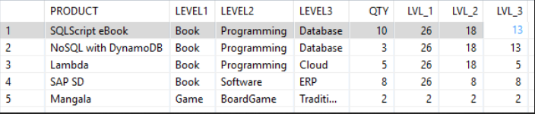

__

HANA model for Parent-Child Hierarchy on ECC sets

In SAP ECC, hierarchies are defined as sets and they are stored in SETNODE and SETLEAF tables. We will leverage these 2 tables to build the Parent-child hierarchy model.
For this document purpose, I have created an account hierarchy in GS01 T code, as a basic set.

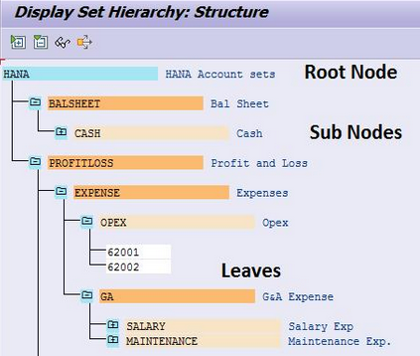

I have created a transaction data table in ECC HANA system, which got some amounts as below –

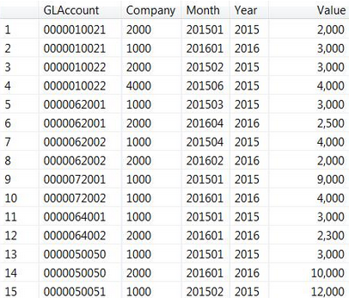

Solution in Detailed
Step 1
1. Creation of ROOTNODE model
SETNODE table is taken into 2 projection nodes and then join the SETNAME with SUBSETNAME.

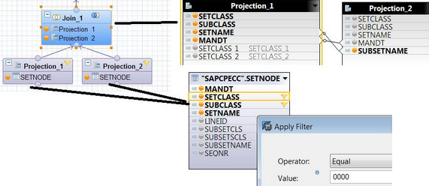

Left outer join on these 2 Projections,

Project1.SETNAME < — > Projection2.SUBSETNAME

with this, all the Subsets which are also the Sets are retrieved.

Note
In this document, SETCLASS and SUBCLASS columns are filtered with values applicable to the hierarchy, SETCLASS = ‘0000’ and SUBCLASS = Blank in all the places used. However, you may configure them as variables or input parameters to dynamically select the required hierarchy class.

2. Aggregation on SUBSETNAME column, this field is taken from Projection 2.
Filter is defined on the SUBSETNAME column to get the records where it is NULL only - with that filter, only ROOT node is taken, in our example, it is HANA.

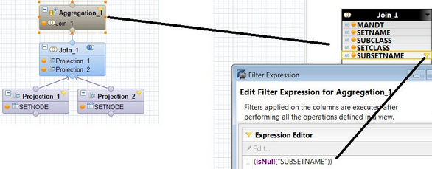

3. Data preview on the RootNode calculation view.
In the below screen shows the complete model of Rootnode calculation view. Also in the data preview, SETNAME is filtered to HANA to display the number of records for SETNAME column. However, it is filtered with input parameter.

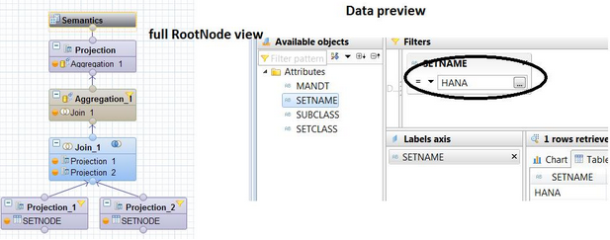

Step 2
Creation of Account Hierarchy Calculation view.
Parent-child hierarchy derivation is split into 4 parts, they are -
- SUBNODES
- Leaves
- LEAVES to SUBNODE link
- RootNode
These 4 parts are explained in detailed,

1.SUBNODES derivation, link is created with 2 columns, they are parent and Child. In this example, the data for SUBNODES would be as in below table.

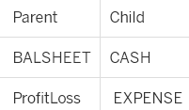

In order to get this display, SETNODE table is taken 2 times in the projections. First projection is named as Parent and the second one as Child. Join is on
Parent.SUBSETNAME < — > Child.SETNAME

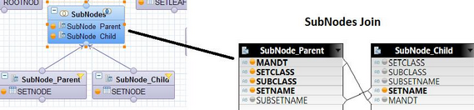

The output columns after the join are –

2. LEAVES derivation, master data values are available in SETLEAF table, so it is taken into a projection.

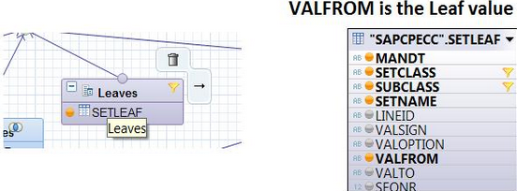

The output columns on this node are –

SELECT TOP 1000 [OrganizationCodeEmitent]
,[AzsCode]
,[DocId]
,[Active]
,[ArmNumber]
,[AzsCodeMDM]
,[AzsDocIdCancellation]
,[BranchNumber]
,[CurrencyCode]
,[CurrencyRate]
,[CurrencyScale]
,[Date]
,[DocType]
,[FiscalNumberString]
,[IdKisnpo]
,[LoyaltyCard]
,[Number]
,[OperatorName]
,[Serial]
,[ShiftDate]
,[ShiftId]
,[ShiftNumber]
,[Status]
,[Type]
,[UNP]
,[System]
FROM [dwbeloil].[fact].[AzsDoc]

Where System=1

SELECT TOP 1000 *
FROM dwbeloil.dbo.AzsFuel_Sales_Payments_CH as sls
Inner join dwbeloil.fact.AzsDoc as doc
On doc.DocId = sls.CheckNum
And doc.ShiftDate = sls.ShiftDate
And doc.AzsCodeMDM = sls.AzsCodeMDM
Where doc.system = 1

SELECT sales.Id AS IDSALE, sales.Active, sales.AzsDocOrganizationCodeEmitent AS EmitentCode, sales.AzsDocAzsCode AS AzsCode, ISNULL(azs_.CodeMDM, 0) AS AzsCodeMDM,
sales.AzsDocDocId AS CheckNum, sales.AzsIncommingFuelId AS InDocId,
sales.AzsIncommingFuelPosition AS InDocPos, sales.Count AS Volume, sales.Count15 AS Volume15, sales.Temperature, sales.Density, sales.Date,
sales.AzsDocShiftDate AS ShiftDate, sales.AzsDocShiftNumber AS ShiftNumber, sales.Tank,
sales.Sum AS SaleSum, sales.SumDiscount AS SaleDiscount,
sales.Price AS RtlPrice, sales.PriceDiscounted AS RtlPrcDiscounted, sales.PriceCurrency,
sales.PriceCurrencyDiscounted AS PrcCurrDiscounted, sales.LoyaltyPoints,
sales.FuelClassCode AS FuelClass, sales.FuelCode AS Fuel
FROM (SELECT c.Id, e.Active, e.AzsDocAzsCode, e.AzsDocDocId, e.AzsDocOrganizationCodeEmitent, e.AzsIncommingFuelId, e.AzsIncommingFuelPosition, e.Count,
e.Count15, e.Temperature, e.Density, e.PriceDiscounted, e.PriceCurrency, e.PriceCurrencyDiscounted, e.AzsDocShiftDate, e.AzsDocShiftNumber, e.Date,
e.Tank, e.SumDiscount, e.Sum, e.Price, e.Position, e.LoyaltyPoints, e.FuelClassCode, e.FuelCode
FROM CHANGETABLE(CHANGES dwbeloil.fact.AzsSaleFuel, 0) AS C LEFT OUTER JOIN
dwbeloil.fact.AzsSaleFuel AS e ON e.Id = c.Id) AS sales LEFT OUTER JOIN
(SELECT CodeMDM, Code, DeletionMark, OrganizationCodeEmitent, IsCashSystem
FROM catalog.Azs
WHERE (DeletionMark = 0) AND (IsCashSystem = 1)) AS azs_ ON azs_.Code = sales.AzsDocAzsCode AND
azs_.OrganizationCodeEmitent = sales.AzsDocOrganizationCodeEmitent
where active is not null

SELECT TOP 1000 [IDSALE]
,[Active]
,[EmitentCode]
,[AzsCode]
,[AzsCodeMDM]
,[CheckNum]
,[InDocId]
,[InDocPos]
,[Volume]
,[Volume15]
,[Temperature]
,[Density]
,[Date]
,[ShiftDate]
,[ShiftNumber]
,[Tank]
,[SaleSum]
,[SaleDiscount]
,[RtlPrice]
,[RtlPrcDiscounted]
,[PriceCurrency]
,[PrcCurrDiscounted]
,[LoyaltyPoints]
,[FuelClass]
,[Fuel]
FROM [dwbeloil].[dbo].[xxx]

SELECT TOP 1000 *
FROM dwbeloil.dbo.xxx as sls
Inner join dwbeloil.fact.AzsDoc as doc
On doc.DocId = sls.CheckNum
and doc.ShiftDate = sls.ShiftDate
And doc.AzsCodeMDM = sls.AzsCodeMDM
--Where doc.system = 1

Migration Hierarchy DataSource

https://blogs.sap.com/2013/02/20/migration-hierarchy-datasource/

Supporting Hierarchical Data in SAP HANA

http://db.in.tum.de/~finis/papers/Hierarchical-Data-SAP-HANA.pdf

Abstract
Managing hierarchies is an ever-recurring challenge for relational database systems. Through investigations of customer scenarios at SAP we found that today’s RDBMSs still leave a lot to be desired in order to meet the requirements of typical applications. Our research puts a new twist on handling hierarchies in SQL-based systems. We present an approach for modeling hierarchical data natively, and we extend the SQL language with expressive constructs for creating, manipulating, and querying a hierarchy. The constructs can be evaluated efficiently by leveraging existing indexing and query processing techniques. We demonstrate the feasibility of our concepts with initial measurements on a HANA-based prototype.

  - INTRODUCTION

Hierarchical relations appear in virtually any business application, be it for representing organizational structures such as reporting lines or geographical divisions, the structure of assemblies, ta’xonomies (tæk'sɔnəmɪ систематика), marketing schemes, or tasks in a project plan. But as tree and graph structures do not naturally fit into the flat nature of the traditional relational model, handling such data today remains a clumsy ('klʌmzɪ неуклюжий, неловкий) and unnatural task for users of the SQL language. We have investigated a number of SAP applications dealing with hierarchies and collected their typical requirements (Sec. II). Within SAP’s Enterprise Resource Planning system, hierarchies are used in the human resources domain to model reporting lines of employees, in asset ('æset активы, фонды) management to keep track of production-relevant assets and their functional locations (e. g., plants, machines, machine parts, tools, equipment), and in materials planning to represent an assembly of components into an end product, a so-called bill of materials (BOM). Due to the limitations of the relational model and SQL, logic for hierarchy handling within these applications has mostly been written in ABAP and therefore runs within the application server. We have identified almost a dozen different implementations of more or less the same hierarchy-handling logic, which is unfortunate not only from an interoperability and maintainability point of view. In most cases, hierarchies are represented in the database schema using a simple relational encoding, and converted into a custom-tailored format within the application, if needed. The most widespread encoding is a self-referencing table resembling an a’djacency (ə'ʤeɪs(ə)n(t)sɪ соседство) list. It is well- known in the literature (e. g., [1]) under the term Adjacency List model. Fig. 1 shows an example instance – table BOM represents a bill of materials. Field id uniquely identifies each part. The hierarchical relationship is established by a self-reference pid associating each row with its respective parent row, the part containing it. The resulting hierarchy is displayed on the left.

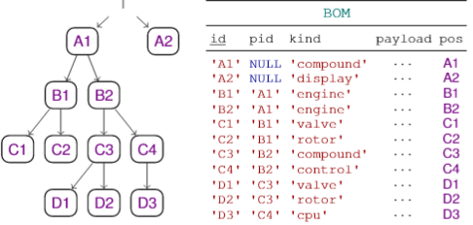
Fig. 1 - Example hierarchy and corresponding table

The only standard hierarchy-handling tools that SQL-based DBMSs today offer are Recursive Common Table Expressions (RCTEs) and some means to define custom stored procedures for working on adjacency lists like BOM. But these tools suffer from certain usability and performance deficiencies. The conventional alternative is to abandon the Adjacency List model and implement a more suitable encoding scheme manually, either on the relational level [1] or within the application (i. e., ABAP), relinquishing any kind of engine support either way. We consider neither RCTEs nor alternative encoding schemes nor any other pur’ported (pə'pɔːt подразумевать, значить) solution we investigated sufficient to meet the common requirements that we have identified (Sec. III).
These requirements call for a solution that seamlessly integrates hierarchical and relational data by combining an expressive front end (new language constructs) with a powerful back end (indexing and query processing techniques), without departing farther than necessary from the philosophy of the relational model. Such a solution is missing to date.
That is not to say the research community has not given enough attention to the underlying technical challenges. In fact, the problem of storing and indexing hierarchical or recursively structured data has been studied deeply in the past decade, in the course of research efforts in the domains of XML and semi-structured databases. While recognizing that many challenges of indexing and query processing have been successfully tackled ('tækl браться, пытаться найти решение, инструмент) previously (e. g., by RCTEs, encoding schemes, and structural joins), we believe there is an open opportunity to reconcile ('rek(ə)nsaɪl согласовывать, примирять) the ideas and techniques from the mentioned areas into a general framework for working with hierarchies in a relational context.
The core concept of our framework is to encapsulate structural information into a table column of a new special-purpose data type NODE (Sec. IV). Our extensions to the SQL query language comprise a small yet essential set of built-in

VI.CREATING AND MANIPULATING HIERARCHIES

The previous section describes query primitives that work on a field of type NODE. In this section, we show how such fields are declared and maintained.

A. Deriving a Hierarchy from an Adjacency List

According to Requirement #6, legacy applications demand for a means to derive a hierarchy from an available table in the Adjacency List format. Derived hierarchies enable users to take advantage of all query functionality ad hoc on the basis of relationally encoded hierarchical data, while staying entirely within the QL (and in particular, without requiring schema modifications via DDL). For this purpose we provide the HIERARCHY expression. It derives a hierarchy from a given adjacency-list-formatted source table, which may be a table, a view, or the result of a subquery -

HIERARCHY
USING source_table AS source_name
[START WHERE start_condition]
JOIN PARENT parent_name ON join_condition
[SEARCH BY order]
SET node_column_name

This expression can be used wherever a table reference is allowed (in particular, a FROM clause). Its result is a temporary table containing the data from the source table plus an additional NODE column named node_column_name. The expression is evaluated by first self-joining the source_table in order to derive a parent-child relation representing the edges, then building a temporary hierarchy representation from that, and finally producing the corresponding NODE column. The START WHERE subclause can be used to restrict the hierarchy to only the nodes that are reachable from any node satisfying start_condition. The SEARCH BY subclause can be used to specify a desired sibling order; if omitted, siblings are ordered arbitrarily. Conceptually, the procedure for evaluating the whole expression is as follows -
- Evaluate source_table and materialize required columns into a temporary table T. Also add a NODE column named node_column_name to T.
- Perform the join T AS C LEFT OUTER JOIN T AS P ON join_condition, where P is the parent_name and C is the source_name. Within the join_condition, P and C can be used to refer to the parent and the child node, respectively.
- Build a directed graph G containing all row IDs of T as nodes, and add an edge between any two rows and that are matched through the join.
- Traverse G, starting at rows satisfying start_condition, if specified, or otherwise at rows that have no (right) partner through the outer join. If order is specified, visit siblings in that order. Check whether the traversed edges form a valid tree or forest, that is, there are no cycles and no node has more than one parent. Raise an error when a non-tree edge is encountered.
- Build a hierarchy representation from all edges visited during Step 4 and populate the NODE column of T accordingly.

The result of the HIERARCHY expression is T.
Note that the description above is merely conceptual; we describe an efficient implementation in Sec. VIII-C. As described, an error is raised when a non-tree edge is encountered.
This way we ensure the resulting hierarchy has a valid tree structure (Req. #7). In our prototype, we also support non-strict hierarchies by deriving a spanning tree over G, with various options controlling the way the spanning tree is chosen.
We omit these advanced options for the sake of brevity. The HIERARCHY syntax is intentionally close to an RCTE and even more so to Oracle Hierarchical Queries. (The self-join via parent_name is comparable to a CONNECT BY via PRIOR in a Hierarchical Query.) However, the semantics are quite different in that by design only a single self-join is performed on the input rather than a recursive join. As our experiments show, this allows for a very efficient evaluation algorithm compared to a recursive join. Furthermore, there is a major conceptual difference to the mentioned approaches -
The HIERARCHY expression does nothing more than define a hierarchy. That hierarchy can be queried by wrapping the expression into a SELECT statement. In contrast, a RCTE both defines and queries a hierarchy in one convoluted ('kɔnvəluːt свернутый, скрученный) statement.
We believe that separating these two aspects greatly increases comprehensibility. As an example, consider again the BOM of Fig. 1. The following statement uses a CTE to derive the pos column from id and pid, then selects the id and level of all parts that appear within part C2

WITH PartHierarchy AS (
SELECT id, pos FROM HIERARCHY
USING BOM AS c
JOIN PARENT p ON p.id = c.pid
SET pos
)

SELECT v.id, LEVEL(v.pos) AS level
FROM PartHierarchy u,
PartHierarchy v
WHERE u.id = 'C2'
AND IS_DESCENDANT(v.pos, u.pos)

The mentioned separation of aspects is clearly visible.
PartHierarchy could be extracted into a view and reused for different queries. One might argue that a RCTE or Hierarchical Query could as well be placed in a view, but that would still not result in a clear definition/query separation, because any potentially needed hierarchy properties (such as LEVEL in the example) would have to be computed in the view definition even though they are clearly part of the query. A query that does not need the level would still trigger its computation, resulting in unnecessary overhead. In contrast, our design allows for deferring the selection of hierarchy properties to the query.

The Parent Child hierarchy in HANA
A parent child hierarchy could be described as the more general case where a node’s semantics is not directly determined by its level (i.e. distance from the root). A parent child hierarchy could be described as the more general case where a node’s semantics is not directly determined by its level (i.e. distance from the root). Parent-child hierarchies are suitable to model tree structures having unbalanced branches of different length and whose depth are not known at design time. Technically, parent-child hierarchies are usually implemented by a recursive self-reference within a table.

